**Data Flow Diagrams:**

Project Design Phase-II

Data Flow Diagram & User Stories

|  |  |
| --- | --- |
| Date | 18 October 2022 |
| Team ID | PNT2022TMID06675 |
| Project Name | Project – EMERGING METHODS FOR EARLY  DETECTION OF FOREST FIRES |
| Maximum Marks | 4 Marks |

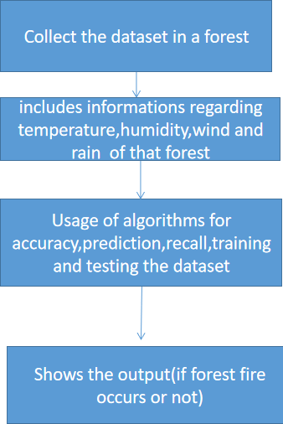

DFD Level 0 (Industry Standard)

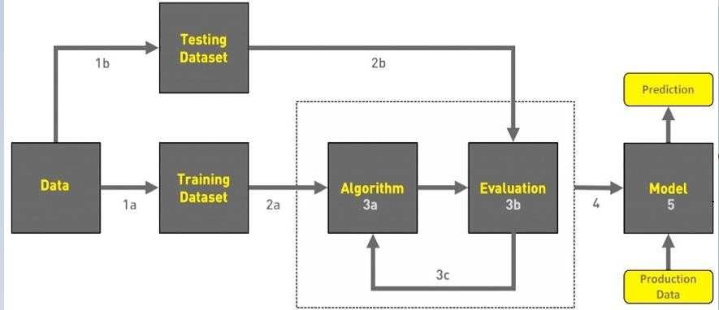

1. COLLECT DATA
2. EVALUATE DATA SET
3. IMPLEMENT ALGORITHMS
4. EVALUATE THE ACCURACY OF EACH ALGORITHMS
5. DISPLAY RESULTS

**User Stories**

Use the below template to list all the user stories for the product.

|  |  |  |  |  |  |  |
| --- | --- | --- | --- | --- | --- | --- |
| **User Type** | **Functional Requirement (Epic)** | **User Story Number** | **User Story / Task** | **Acceptance criteria** | **Priority** | **Release** |
| Environmentalist | Collect the data | USN-1 | As an Environmentalist,it is necessary to collect the data of the forest which includes  temperature,humidity,wind and rain of the forest | It is necessary to collect the right data else the  prediction may become wrong | High | Sprint-1 |
|  |  | USN-2 | Identify algorithms that can be used for prediction | To collect the algorithm to identify the accuracy level of each algorithms | Medium | Sprint-2 |
|  |  | USN-3 | Identify the accuracy of each algorithms | Accuracy of each algorithm-calculated so  that it is easy to obtain the most accurate output | High | Sprint-2 |
|  |  | USN-4 | Evaluate the Dataset | Data is evaluated before processing | Medium | Sprint-1 |
|  |  | USN-5 | Identify accuracy,precision,recall of each algorithms | These values are important for obtaining the right output | High | Sprint-3 |
|  |  | USN-6 | Outputs from each algorithm are obtained | It is highly used to predict the effect and to take precautionary measures. | High | Sprint-4 |